Vaccine Recipients
Maritza Beniquez, Resident Nurse, Emergency Department, University Hospital
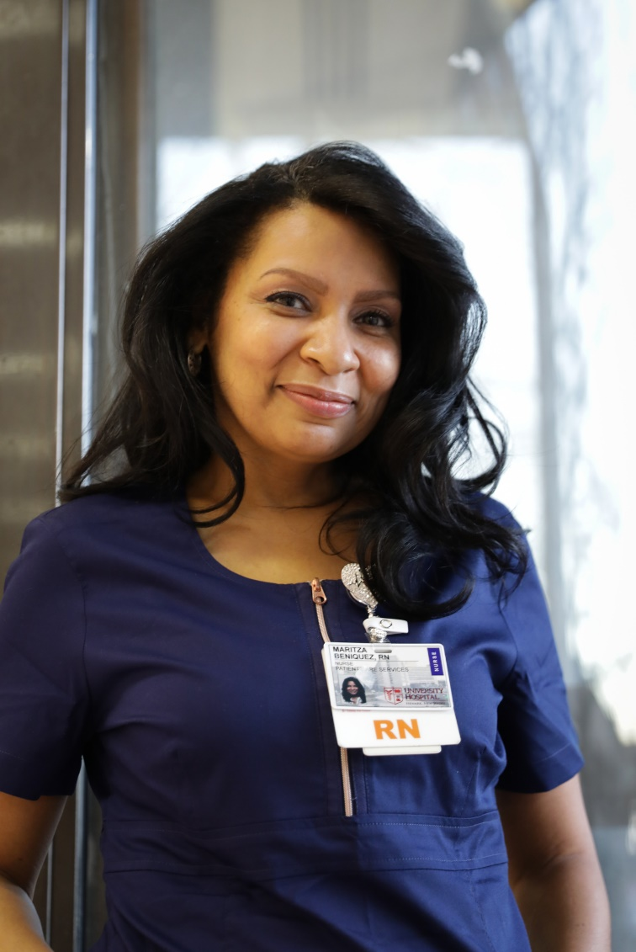
Maritza Beniquez is a Resident Nurse at the Emergency Department of University Hospital. She previously worked as a Staff Nurse at the Emergency Department prior to completing her residency at University Hospital. She previously worked as the Staff Nurse of the Emergency Room Department at Hackensack University Medical Center from November 2015 to March 2016. Before that, she worked as the Registered Nurse at CarePoint Health System from October 2014 to October 2015. She graduated from Hudson County Community College with an Associate’s degree in Science, from CarePoint Health School of Nursing with an Associate’s degree in Registered Nursing and from the Chamberlain College of Nursing with a bachelor’s degree in Registered Nursing.

Robert L. Johnson, Dean, Rutgers New Jersey Medical School
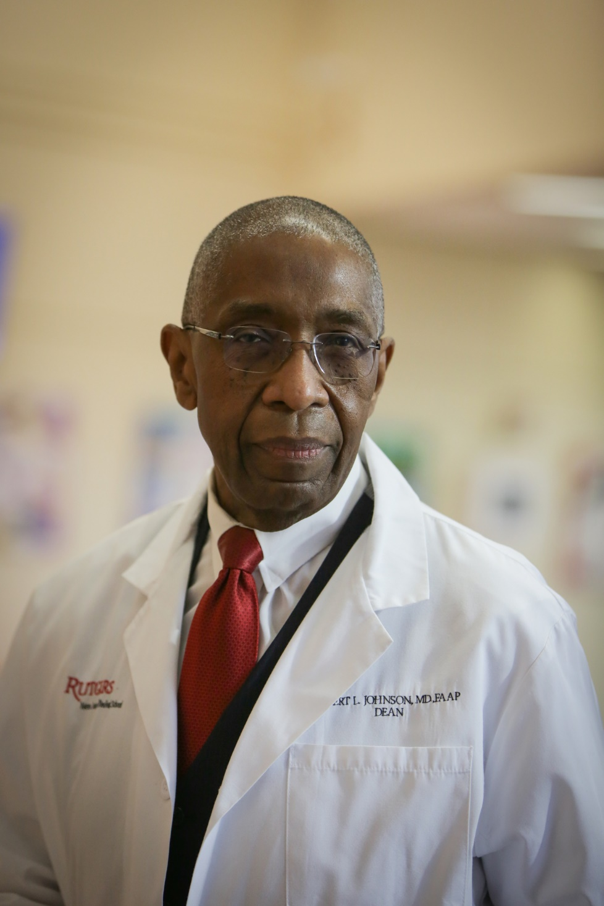
Robert L. Johnson has been the Dean of Rutgers New Jersey Medical School since July 2013. In addition to serving as the Dean, he also has worked as the Director of Adolescent and Young Adult Medicine since July 1976. He previously worked as the Dean of the University of Medicine and Dentistry of New Jersey (UMDNJ) New Jersey Medical School from 2005 to June 2013. From 2000 to 2005, he worked as UMDNJ New Jersey Medical School’s Chair of Pediatrics. Johnson graduated from Alfred University with a bachelor’s degree in Pre-Medicine/Pre-Medical Studies in 1968 and later from UMDNJ New Jersey Medical School with an M.D.

Justin Sambol, Senior Associate ean for Clinical Affairs, Rutgers New Jersey Medical School
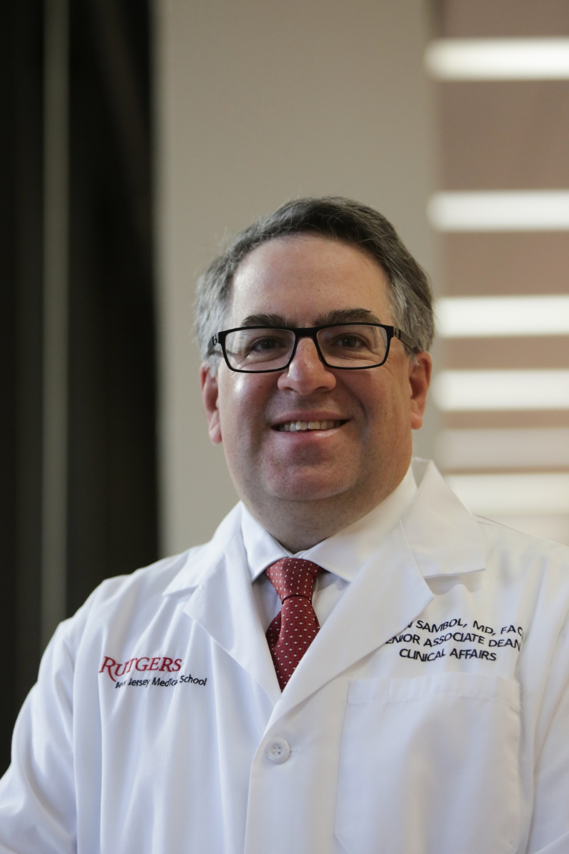
Justin Sambol has the been the Senior Associate Dean for Clinical Affairs at Rutgers New Jersey Medical School since January 2015. He also has worked as the Chief of the Division of Cardiothoracic Surgery for Rutgers New Jersey Medical School since July 2007. He previously worked as Rutgers New Jersey Medical School’s Vice Chair of the Department of Surgery from 2011 to 2016. In addition to his work with Rutgers, since 2019 Sambol also works as the Chief Medical Officer for Operations Rutgers Practices at RWJBarnabas Health. He also has worked as enter since June 2017 and is a Medical Advisor for OpticSurg Inc. Sambol graduated from the University of Pennsylvania with a B.A. in Biological Basis of Behavior, from the University of Medicine and Dentistry of New Jersey with an MD, and is currently attending the Isenberg School of Management at the University of Massachusetts at Amherst for an M.B.A. in Business Administration and Management.

Yvelisse Covington, Medical Office Assistant, Obstetrics and Gynecology (OB/GYN) Clinic, University Hospital
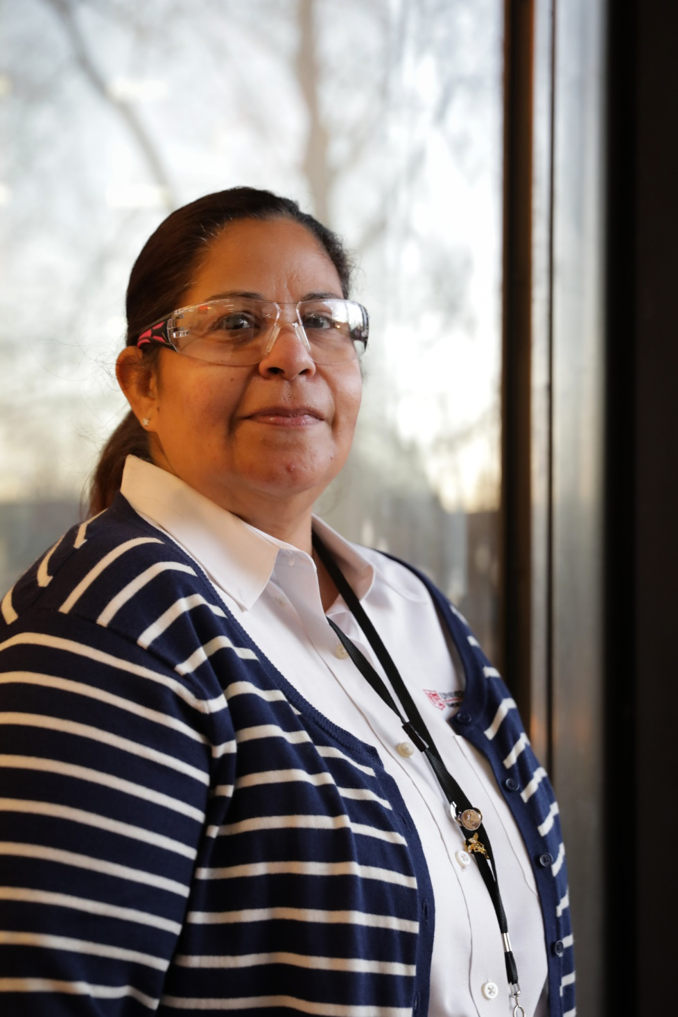
Yvelisse Covington is the Medical Office Assistant at the Obstetrics and Gynecology Clinic at University Hospital in Newark, New Jersey. She has worked with University Hospital for over 32 years. She graduated from East Side High School in Newark, New Jersey in 1986 and currently lives in Elizabeth, New Jersey.

Charles Farmer, Doctor, Emergency Department, Rutgers New Jersey Medical School
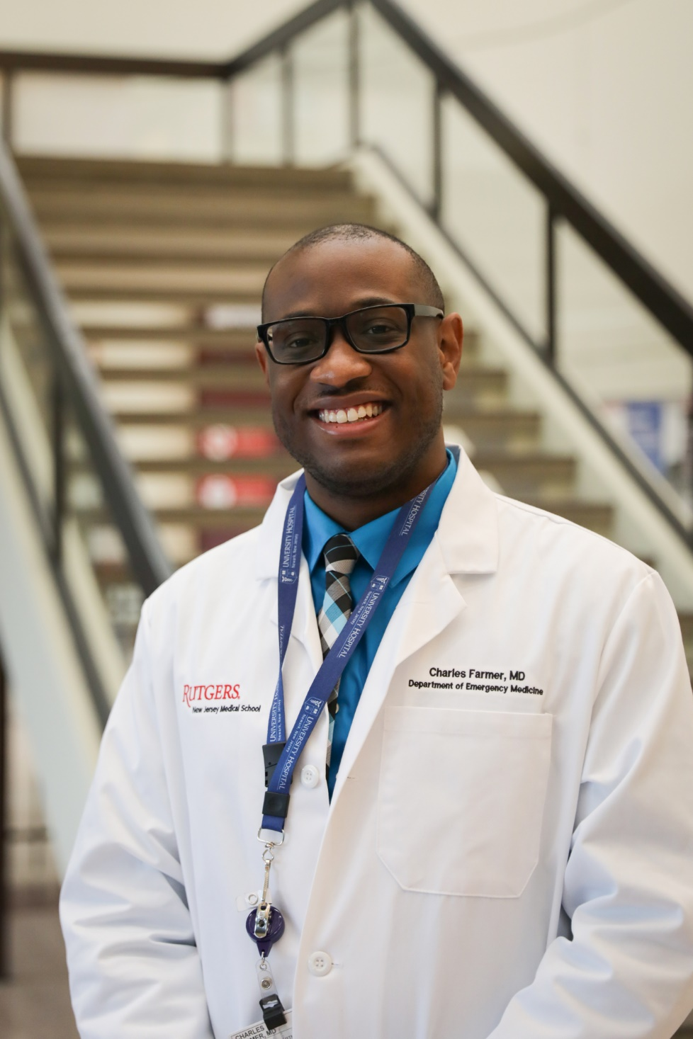
Dr. Charles Farmer has worked as a Doctor for the Emergency Department at Rutgers New Jersey Medical School for a little over a year in addition to being a recent graduate of the NYU/Bellevue Emergency Medicine Residency Program. During his residency, Dr. Farmer was a member of the Social Emergency Medicine Academy, which is a resident leadership group that focused on the fundamentals of social emergency medicine. He developed a new teaching elective that allowed senior residents to focus solely on observing students on shifts. Dr. Farmer graduated from Seton Hall University with a B.S. in Biology and later from John Hopkins School of Medicine with an M.D.

